Project Design Phase
Problem – Solution Fit Template

Date | 6 July 2026
Team ID
Project Name | Online Complaint Registration
Maximum Marks | 2 Marks

Problem – Solution Fit Template:
The Online Complaint Registration System identifies common issues faced by citizens while registering and tracking complaints, such as lengthy manual processes, lack of transparency, delayed responses, and difficulty in monitoring complaint status. The proposed solution addresses these challenges by providing an easy-to-use online platform for complaint registration, complaint tracking, status updates, and administrative management. This ensures that the solution effectively meets user needs while improving transparency, efficiency, and service quality.
Purpose:
Solve complaint management problems through a centralized online platform. Improve user convenience through online complaint registration and tracking.
Enhance transparency with real-time status updates and notifications.
Build user trust by ensuring timely complaint resolution.
Understand citizen needs and improve public service delivery.
Template:

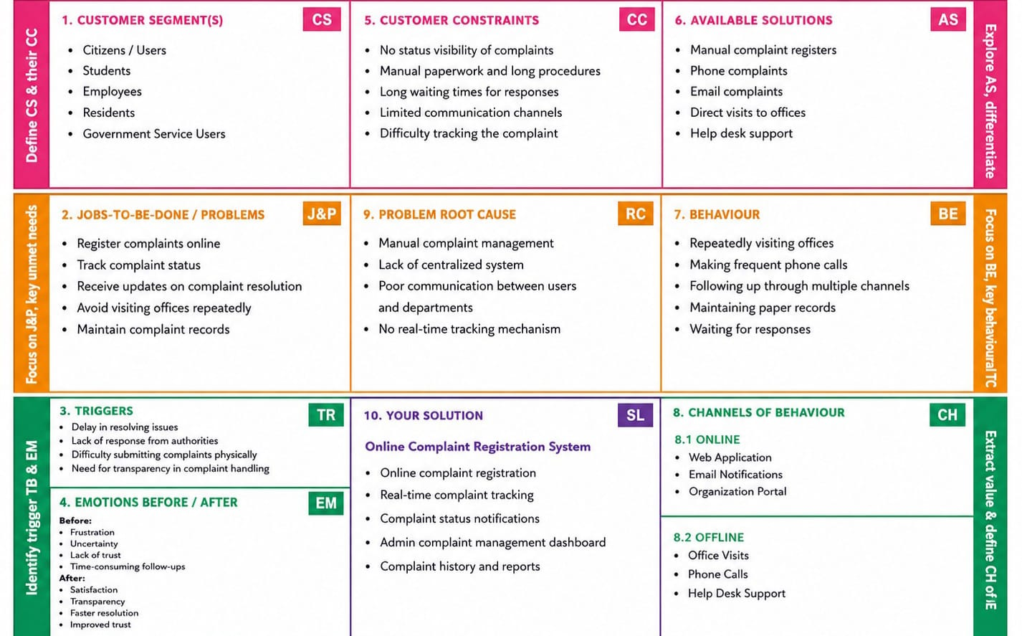

References:
- https://www.ideahackers.network/problem-solution-fit-canvas/
- https://medium.com/@epicantus/problem-solution-fit-canvas-aa3dd59cb4fe

